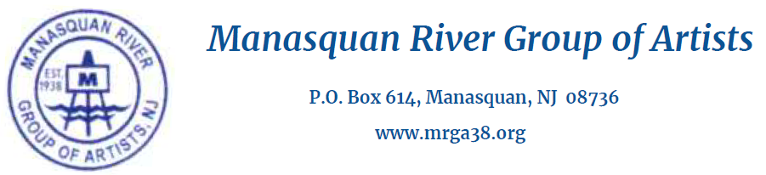
MRGA members must reside in the Monmouth/Ocean County area at least five months of the year, attend at least two meetings per year, pay annual dues, and participate in at least one MRGA art exhibit per year.

Name: Click here to enter text.
Address: Click here to enter text.
City: Click here to enter text. State: Click here to enter text.Zip: Click here to enter text.
Email: Click here to enter text.
Home Phone: Click here to enter text. Cell Phone: Click here to enter text.
Website: Click here to enter text.
Art-related Education/Memberships: Click here to enter text.

Briefly describe your current choice of artistic media and subject matter: Click here to enter text.
I am interested in volunteering to assist with: Please check all that apply
☐ | Committee Work | ☐ | Hospitality | ☐ | Art Shows
☐ | Programs | ☐ | Publicity | ☐ | Teaching/Demo

The Manasquan River Group of Artists is a culturally-based organization dedicated to the promotion and encouragement of the visual arts in our local communities

Please save this completed application and email to mrga38cal@gmail.com
Include 5 jpegs of your work, completed within the last 3 years, with dimensions & medium.
Thank you for your interest in the MRGA!

